Weekly Construction Progress Report – Week 38
Harrow Bay Offshore Wind · 14 Sep – 20 Sep 2026
Elena Márquez · 21 September 2026 · HB-PM-RPT-2026-W38

1. Summary
No monopile was installed this week; the total remains 13 of 40. The foundation campaign is 3 piles behind the Rev 2 baseline (16 planned). Waiting on weather amounted to 71 hours – well above the planning allowance of 25 hours per week.
Area | Status | Comment
Overall schedule | Red | 13/40 monopiles vs. 16 planned
Foundations | Red | TPs installed: 13
Offshore substation | Green | Topside installed 19 Aug
Cables | Red | Export cable 2 delay – HB-RISK-017
HSE | Amber | Near miss reported

2. Progress
Metric | This week | Cumulative | Plan (cum.) | Variance
Monopiles installed | 0 | 13 | 16 | -3
Transition pieces installed | 1 | 13 | – | –
Waiting on weather (h) | 71 | 494 | – | –
Persons on board (avg.) | 103 | – | – | –
Man-hours MV Sea Atlas | 8,590 | 195,710 | – | –
Lost time injuries | 0 | 0 | 0 | 0
Recordable injuries | 0 | 1 | – | –
Near misses reported | 1 | 5 | – | –
HSE observation cards | 14 | – | – | –

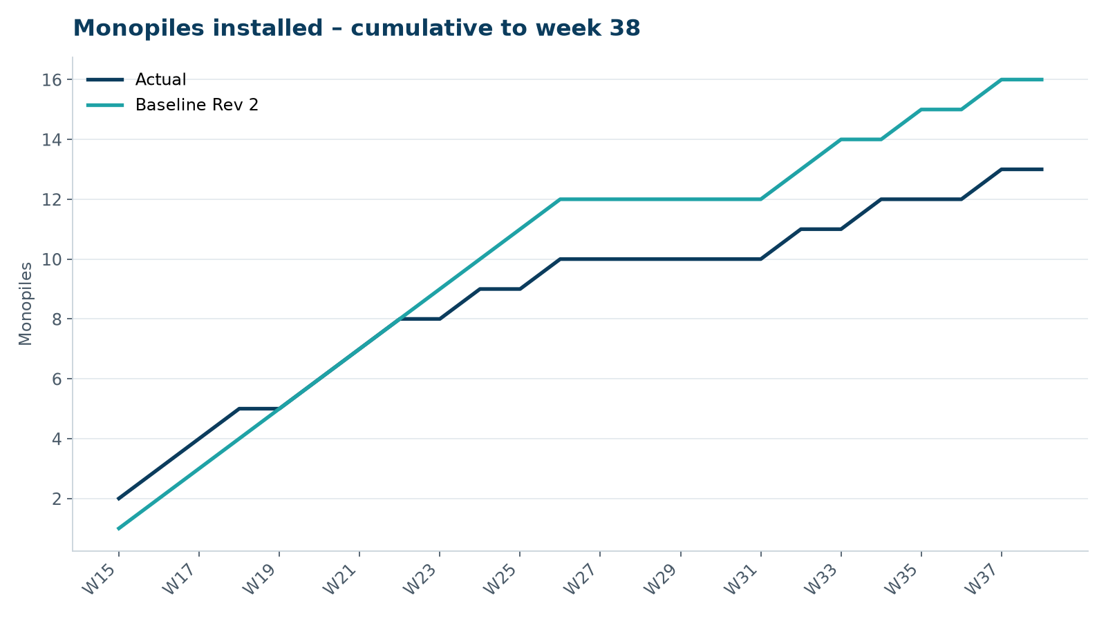
Figure 1 – Monopile installation progress, W15 to W38

3. Key activities this week
- 71 hours waiting on weather – the worst week of the campaign so far.
- MV Sea Atlas jacked down and preloaded at HB-A14 on 19 September, then held on standby.
- Atlas Marine confirmed availability of charter option 2 (+45 days).

4. Health and safety
No lost time injuries. One near miss reported (minor; closed out on board). 14 observation cards submitted; top theme: access to the TP platform.

5. Environment
- No piling this week; passive acoustic monitoring stations HB-PAM-01 to -04 operational.

6. Issues and risks
- HB-RISK-017 export cable 2 delay – recovery programme received; resequencing of cable lay campaign in progress.
- HB-RISK-001 weather: 71 h downtime this week.
- HB-RISK-029 monopile campaign into winter – recovery plan in preparation.

7. Look-ahead next week
Install HB-A14; SteerCo decision on charter option 2.
Prepared by Project Controls (Gareth Lewis); approved by Elena Márquez. Distribution: project team, Steering Committee, Halden Turbine Systems, Lenders' Technical Adviser.

